TITLE IN ENGLISH

TITULO EM PORTUGUÊS

TÍTULO EN ESPAÑOL

Author's full name without abbreviations

Recibido: xx/xx/202x | Aceptado: xx/xx/202x | Publicación en línea: xx/xx/202x.

Abstract

The abstract of the forthcoming publication aims to provide a concise overview of the study at hand. Considering the justification and underlying problem, the objective is to clearly define the research objectives. To do so, an appropriate and well-founded methodology will be followed. Thus, upon analyzing the results obtained, significant contributions to the field of study are observed. These findings allow us to conclude that the work has achieved its proposed objectives. It is recommended that the abstract contain between 150 and 250 words to ensure the necessary precision and conciseness.

Keywords: Between 4 and 6 keywords, separated by periods. For example: Law. Freedom. Homeland. Brazil.

Resumo

O resumo do trabalho a ser publicado visa fornecer uma visão concisa do estudo em questão. Considerando a justificativa e o problema subjacentes, objetiva-se claramente definir os objetivos da pesquisa. Para tanto, seguirá uma metodologia adequada e bem fundamentada. Desse modo, ao analisar os resultados obtidos, percebe-se que há contribuições significativas para o campo de estudo. Essas descobertas permitem concluir que o trabalho alcançou seus objetivos propostos. Recomenda-se que o resumo tenha entre 150 e 250 palavras para garantir a precisão e a concisão necessárias.

Palavras-chave: Entre 4 e 6 palavras-chave, separadas por ponto. Por exemplo: Direito. Liberdade. Patria. Brasil.

Resumen

El resumen de la próxima publicación tiene como objetivo proporcionar una visión concisa del estudio en cuestión. Considerando la justificación y el problema subyacente, el objetivo es definir claramente los objetivos de investigación. Para ello, se seguirá una metodología apropiada y bien fundamentada. Así, al analizar los resultados obtenidos, se observan contribuciones significativas al campo de estudio. Estos hallazgos nos permiten concluir que el trabajo ha alcanzado sus objetivos propuestos. Se recomienda que el resumen contenga entre 150 y 250 palabras para garantizar la precisión y concisión necesarias.

Palabras clave: Entre 4 y 6 palabras clave, separadas por puntos. Por ejemplo: Ley. Libertad. Patria. Brasil.

Esta obra está bajo una Licencia CreativeCommons Atribución- NoComercial 4.0 Internacional

INTRODUCTION

The introduction of the article should contain a contextualization of the study to be reported, with the motivations and conditions under which the research was conceived. In addition, the motivating question and justification for the research should also be added. These elements make the intellectual contributions of the study clearer to readers, making the article more relevant for publication.
Each article published in the journal must have a maximum of 6 authors. In the case of additional authors, an extra fee is charged and should be consulted by contacting the Editorial Team. This introductory section, like the others, should be in Times New Roman font, size 12, with 1.5 line spacing. Each article to be published should have a maximum of 25 pages, including references, and may be written in Portuguese, English, or Spanish.
At the end of the introduction, the objectives of the work must be clearly outlined in a specific and measurable manner. If desired, it is possible to create a separate sub-item for the objective. In addition, it is essential that the elements of this section be formulated in an achievable manner, ensuring that the reader fully understands the scope of the study and what will be addressed and evaluated.

THEORETICAL FRAMEWORK

The theoretical framework in a study comprises a critical and organized analysis of the literature relevant to the topic, providing a theoretical contextualization and defining the key concepts. It must comprehensively contain theories, models and previous research, identifying gaps, contradictions and consensuses in the literature that are important for the focus of the work being developed.

Title of graphic elements (figures, charts, tables, etc.)

The title of the graphic elements should explain the content of the image in a concise but discursive manner, should be written in size 10 font, with 1.0 spacing, and centered on the page. Figures should be numbered with sequential Arabic numerals within the text as a whole, and preceded by the word “Figure.” E.g.: Figure 1, Figure 2, Figure 3, etc.
For example:

Figure 1. Place where the experiments were conducted.
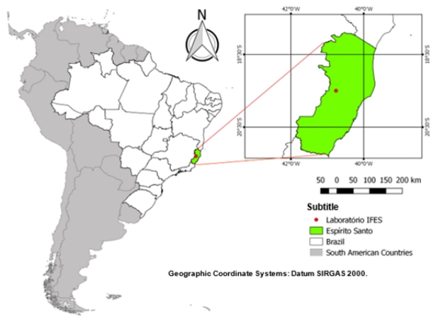
Source: Adaptado de PIFFER, P. F. Mapas do Brasil. Revista Mundos, v.1 n3, 2023.

Table 1. Partial list of subdivisions implemented by Companhia City until 1951 in the city and São Paulo.
No | Neighborhood name | Área (m²) | Ano
1 | Jardim America | 1.091.118 | 1915
2 | Anhangabaú | 170.849 | 1917
3 | Butantan | 2.341.379 | 1918
4 | Alto da Lapa and Bela Aliança | 2.126.643 | 1921
5 | Pacaembu | 998.130 | 1925
6 | Alto de Pinheiros | 3.669.410 | 1925
7 | Vila America | 186.200 | 1931
8 | Vila Nova Tupi | 180.000 | 1931
Source: Arquivo da companhia city, sem data.

Board 1. Resultados.
RESULT | CONTEST
3 absent | Administrative Technician in Education
3 granted | Higher Education Teacher
Panel planned, but not carried out because there were no self-declared candidates. | Higher Education Teacher
Panel planned, but not carried out because there were no self-declared candidates. | Administrative Technician in Education
34 absent | Higher Education Teacher
39 granted | Administrative Technician in Education
Source: Prepared by the authors.

Any image containing the identification of individuals must be blurred to prevent facial recognition, ensuring the protection of identity and preserving the dignity and individual freedom of those involved.

Figure 2. People walking along Avenida 15 de Novembro.
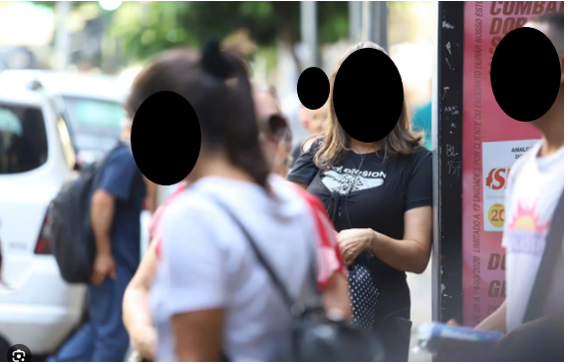
Source: Prepared by the authors themselves.

Section Subtitle

Titles should be in uppercase, bold, size 12.
Subtitles should be presented with only the initial letters capitalized, written in bold, size 12. Following the example:

Table 2. Sequence of formation of titles.
Type | Format
Primary Section Title | INTRODUCTION
Secondary Section Title | Search Type
Tertiary Section Title | Definition of Concepts
Title of the quaternary section | Concept options
Title of section quinaria | Bold and italicized
Title of the senary section | No bold and italics
Source: DCS, 2024.

Text Citation

Quotations inserted in the body of the text must follow ABNT standards.
In indirect quotations, when the author's name is not mentioned in the body of the text, their surname should be indicated in parentheses, in capital letters, followed by a comma and the year of publication of the work (for example: Barbosa, 1980). If the author's name is already included in the text, only the year of publication should be indicated in parentheses immediately after the name, as in the example:
Morais (1995) points out that...
For direct quotations (literal transcription of the original text), the page number where the quoted passage is found should be specified immediately after the publication date (e.g., Mumford, 1949, p. 513). Citations referring to different works by the same author, published in the same year, should be distinguished by adding a lowercase letter immediately after the year of publication, without any spacing (e.g., Silva, 2020a; Silva, 2020b).
When the cited work has two or three authors, their surnames should be indicated and separated by semicolons, followed by the year of publication (Oliveira; Leonardo, 1943).
In cases where the work has more than three authors, only the surname of the first author should be mentioned, followed by the expression et al. and the respective year (Gille et al., 1960).
Direct quotations of up to three lines should be inserted in the body of the text, in quotation marks, followed by the author's surname, year of publication, and page number.
Direct quotations longer than three lines should be presented in a separate paragraph, indented 4 cm from the left margin, in 10-point font, single-spaced and without quotation marks. At the end of the quotation, the author's last name, year of publication, and page number should be included.
Quotations in a foreign language should be presented in the same language as the text and the citation should include the indication “own translation.” In a footnote, present the quotation in its original language.
Latin expressions (idem, ibdem, passim, loco citato, and sequentia) as well as the expression see (Cf.) cannot be used in citation references in the body of the text. The expressions apud and et al. can be used in the body of the text and in italics. Below are some examples of citations:

Direct quote with more than three lines

Harvey (1993, p. 112) adds to all this another factor,

[...] while opening a radical perspective by recognizing the authenticity of other voices, postmodern thinking immediately seals these other voices from access to more universal sources of power, circumscribing them in a ghetto of opaque otherness, of the specificity of one or another language game.

Direct quote with less than three lines

According to Prunes (2000, v. 2, pp. 647-648) ‘the applicants’ lack of conformity, supported by a technical expert report ...’.

Indirect Citation

According to Herculano (2021), the use of optimization techniques is fundamental to generate organic traffic.
According to Herculano (2021, p. 409), content marketing consists, among other things, in authoritative writing on the subject (example with page indication, which is not mandatory).
Visibility on the internet is often generated by the investment in digital marketing (Herculano, 2021).

Indirect Quotation from two authors

According to several authors (Herculano, 1996; Netherlands, 2010), digital marketing is important for growth...
Digital marketing helps companies grow (Herculano, 1996; Netherlands, 2010).

Indirect Citation of various works

Digital marketing can improve communication between brand and audience (Herculano, 1996, 2016, 2018).
According to Herculano (1996, 2016, 2018), digital marketing is a good strategy for advertising a new product.

Indirect Quotation from more than four authors in the same work

According to Herculano et al. (2018) Social media publishing is a new way to make a company more visible on the market.
Social media publishing involves inserting arts into the feed and stories (Herculano et al, 2018).

Quotation from the author with more than one work published in the same year

Social media makes businesses more visible (Herculano, 1998a).
According to Herculano (1998a, 1998b), social media makes businesses more visible.

Numerical Citation Method

This is a method of citation indicated by numbers, as the name already says. See the example below:
According to Herculano, digital marketing is a strategy capable of building a qualified target audience for the brand (2);
According to Herculano, SEO strategies can help you grow a brand².

METHODOLOGY

The methodology of an article outlines the procedures employed to conduct the research, including the type of study, sample selection, data collection and analysis methods, ethical considerations, and limitations of the study. Its detailed and transparent description is essential to guarantee the replicability and reliability of the results, in addition to providing a solid basis for the interpretation and generalization of the findings.

Formulas and Equation

In the midst of a text, formulas and equations should be represented in line. A larger spacing should be used to accommodate their elements (exponents, indices, and others). When presented outside the paragraph, they should be left-aligned. If there are multiple formulas or equations, they should be identified with sequential Arabic numerals throughout the text and enclosed in parentheses ( ) at the right end of the line. If formulas or equations are divided into multiple lines due to lack of space, they should be interrupted before the equal sign "=" or after addition and subtraction signs.
Example:

$d \left(AB\right)= \frac{dV }{dh}x 100$ (1)

where:

d(AB)= slope expressed as a percentage
dV= vertical distance (equidistance)
dH = horizontal distance

Example:

$\left({\begin{matrix}1 \\ 5 \\ 2\end{matrix} \atop 0}\right)=\left(\begin{matrix}1 & 2 \\ 0 & 5\end{matrix}\right)$ (2)

Marker

Markers are enumerative divisions referring to a period of the paragraph. The following configuration:
a) the text preceding the first marker ends with a colon;
b) they begin at the paragraph indent and are written with normal spacing;
c) they are numbered with lowercase letters in alphabetical order, followed by a closing parenthesis. If the number of bullets exceeds the number of letters in the alphabet, use doubled letters: aa), ab), ac), etc;
d) the text of the marker begins with a lowercase letter, except if it begins with proper names, and is closed with a semicolon, except for the last one, which is closed with a period.
As in the example below:
a) markers are spaced at a left indentation of 0.75 by an offset of 0.5;
b) markers are spaced at a left indentation of 0.75 by an offset of 0.5;
c) markers are indented 0.75 to the left by an offset of 0.5.

RESULT AND DISCUSSION

The results and discussion of an article must be presented in a clear and organized manner, based on the data collected and the analyzes carried out during the study. Initially, the results must be presented in an objective and concise way, using tables, graphs and statistics, if applicable, to highlight the main findings. Then, in the discussion section, the results are interpreted in light of existing literature, highlighting similarities, differences and implications for theory and practice.
Furthermore, limitations of the study and possible directions for future research are discussed. It is essential that both the results and the discussion are based on solid evidence and that they contribute significantly to the advancement of knowledge on the topic addressed.

CONCLUSION

The conclusion of an article should summarize the main findings of the study succinctly, highlighting the significant contributions to the research field. It should reiterate the objectives of the study and summarize the most important findings, emphasizing their relevance and practical or theoretical implications.

ACKNOWLEDGEMENTS

Optional section for acknowledgments, in which the author may mention funding agencies, supporting institutions, or any other contributions deemed relevant.

REFERENCES

Bibliographic references should be organized in alphabetical order. Their formatting should follow the following standard: font size 12, single spacing, and left alignment. Examples of references are provided below.

Books with only one author
LAST NAME, First Name. Title: Subtitle (if any). Edition (if any). Place of publication: Publisher, year of publication.

Example:
KRENAK, A. Ideias para adiar o fim do mundo. São Paulo: Companhia das Letras, 2019.

Books with only one author
LAST NAME, First Name. Title: Subtitle (if any). Edition (if any). Place of publication: Publisher, year of publication.

Example:
ARUZZA, C; BHATTACHARYA, T; FRASER, N. Feminismo para os 99%: um manifesto. São Paulo: Boitempo, 2019.

Book with more than three authors
LAST NAME, First Name et al. Title: Subtitle (if any). Edition (if any). Place: Publisher, year of publication.

Example:
DILGER, G. et al. Descolonizar o imaginário: debates sobre pós-extrativismo e alternativas ao desenvolvimento. São Paulo: Fundação Roxa Luxemburgo, 2016.

Reference to the Federal or State Constitution
PLACE. Title (year). Description. Place of the constituent body, year of publication.

Example:
BRASIL. Constituição (1988). Constituição da República Federativa do Brasil. Brasília, DF: Centro Gráfico, 1988.

Journal or Magazine Article
LAST NAME, abbreviated First Name. Article Title. Journal Title, Place of publication, volume number, initial-final pages, month and year.

Example:
KILOMBA, G. A máscara, Revistas USP, n. 16, p. 23-40, 2016.

Article in an event
LAST NAME, First Name. Title of the presented work. In: EVENT TITLE, event number, year of realization, place (city of realization). Title of the document (proceedings, abstracts, etc.). Place: Publisher, year of publication. Initial-final pages.

Example:
SILVA, J. A contribuição de Paulo Freire na Pedagogia. In: JORNADA DE PEDAGOGIA, nº 3, 2019, Florianópolis. Resumos. Florianópolis: Editora X, 2020, p. 20-50.

Reference to monograph, dissertation, or thesis
LAST NAME, First Name. Title: Subtitle (if any). Year of presentation. Number of pages or volumes. Category (concentration area) - Institution, Place, year of defense.

Example:
CARNEIRO, A. S. A construção do outro como não-ser como fundamento do ser. 2005. Tese (Doutorado em Educação) – Curso de Educação – Universidade de São Paulo, São Paulo, 2005.

Highest academic qualification, Training institution, City, State, Country. E-mail: xxxxx@hotmail.com Orcid: https://orcid.org/0000-0000-0000-0000

